Vehicle Speed Detection Using Image Processing Techniques

Abhinav Ganesh

18-799K

**1. Introduction**

As the research in the field of signal and image processing grows we are starting to see more and more practical applications of this research in our daily lives. Typically the applications have been more prevalent in military settings but they can be just as effective in civilian environments. Over the years with the increased urbanization of many cities around the world, traffic monitoring has become a vital part of the data knowledge ecosystem. Current modern day utilities such as Google Maps and GPS systems feed real time data to users to give them a better of idea of traffic patterns and help plan their trips more efficiently. Traffic monitoring systems are also vital for law enforcement officials, not only to penalize speed limit violators but to also aid in the quick and efficient allocation of resources in the event of sudden traffic congestion. Historically traffic-monitoring systems have been built using either pavement invasive methods such as with inductive loops and magnetometers or non-pavement invasive methodologies such as with microwave radar, active/passive infrared, and acoustic detectors. Many of these traditional methodologies are limited because they can only collect certain types of data and do not allow for a more holistic understanding of traffic conditions. Another limiting factor is that systems like inductive loops have extra maintenance and installation costs. As an alternative to these methods, computer vision based traffic systems have come to the forefront. Vision based systems use various signal-processing techniques to extract more meaningful metrics from traffic data. These systems are also preferable because maintenance and installation costs are relatively low (as the only overhead is in the cost associated with the camera being used). In order to get an idea of some of the price differences between theses three classes of systems (invasive methods, non-invasive, and video systems) I have procured some approximate costs from various sources [8-10]. They are detailed in Table 1 below:

|  |  |  |
| --- | --- | --- |
| System Class | Type of System | Approximate Cost |
| Pavement - Invasive | Inductive Loops | $26,100 |
| Pavement - Non-Invasive | Sensys Wireless Detector | $9,700 |
| Video | Iteris Video Detection | $7,000 |

Table : Cost Comparison

The costs shown above include mainly the initial cost of setup but the projected cost over their respective lifecycles follows a similar pattern. Pavement involved methods require routine checkups and these subsequently cause lane closures and prove to be a disruption to traffic flow. Inductive loops for example can suffer from a variety of natural stresses that can cause deterioration. These stresses include oxidation as well as mechanical stress from freeze/thaw cycles [10]. Such stresses naturally drive up maintenance costs. Video systems however require much less overhead with regards to maintenance. Maintenance procedures can be as simple as changing the lens on a camera or recalibrating the visual system. Video systems also provide the added advantage of ease of use/installation. The Iteris video detection can be setup in about 30 minutes, which is in stark contrast to inductive loops or wireless sensor technologies [9]. Looking at traffic monitoring systems purely from a cost perspective it has become obvious that it is in the best interest of taxpayers and law enforcement officials to choose video based approaches. Extensive research is being performed in an effort to mitigate the perceived weaknesses of video detection systems. These weaknesses include sensitivity to lighting conditions, shadows, and reflections. The impact that a robust video based system could have is tremendous. As the table above shows, transportation departments could save nearly three times as much by using video systems on a per unit basis. This not only brings the total cost down but also provides the opportunity to monitor more intersections and traffic areas. With more traffic areas monitored we can potentially collect more traffic relevant data to essentially create a “smart-city” and more efficiently allocate our resources to allow for people to get to their destinations faster and perhaps even reduce the likelihood of vehicle related accidents.

**2. Literature Survey**

There has been much literature regarding these vision-based systems, specifically in the context of measuring vehicle speed. Various speed detection algorithms have been proposed over the years. One of the more basic and early algorithms was proposed by Takaba [1] whereby physical markers are drawn on an image and the time taken for vehicles to cross the markers are used to determine speed. This technique is effective provided that these markers are perpendicular to the road surface and the road surface is devoid of curves or other obstructions. Xiao and Yung [2] have documented many of the other speed detection algorithms that have been used. One technique they reference is that of applying geometric transformations to pixel distances and coordinates to get real world speed. Another referenced work is that of Dailey and Li [3] who again used geometric transformations to calculate speed while using un-calibrated cameras and distributions of vehicle lengths. Their work is especially interesting because they point out how much work hasn’t been done to measure speed from un-calibrated cameras. They use a very practical approach whereby they try to make many key assumptions to reduce the difficulties associated with not knowing camera focus, tilt, or angle. Some of the assumptions they make are very similar to the assumptions I make with my algorithm. For example they assume that the speed of the vehicles being measured is finite and follow both legal and physical limits. They assume that vehicle movement is smooth, vehicle motion is constrained to the road plane, and finally that the length of the vehicles in the images are realizations from a known vehicle length distribution. Using these assumptions they start off by tracking vehicles using frame differencing, followed by a dynamic estimation of scale factor in feet per pixel, and finally they calculate speed using this distance travelled and the interframe delay to calculate a speed. Xiao and Yung also reference slightly more complicated algorithms such as the one proposed by Schoepflin and Dailey [4] in which speeds are calculated using calibrated cameras based on a cross correlation technique that is applied to a group of moving vehicles. In this research they try to estimate speeds while using a unique camera calibration technique. Unlike previous work done in this field they try to perform this calibration with *a priori* calibration information unavailable (thus using only information present in the scene being observed). They assume a planar road and a pan-tilt-zoom camera model as part of their research model. By making these assumptions they are able to estimate the distance between lane markers as means of scaling from 2-D distances to 3-D distances. They also estimate vehicle speed by tracking multiple vehicles at a time as opposed to tracking one vehicle at a time. They do this by estimating the 3-D shift of all the vehicles in a set lane between image frames. This calculation allows them to calculate a mean speed. Xiao and Yung [2] themselves present an interesting algorithm whereby they only use 2 consecutive frames and use a calibrated camera along with a block matching algorithm to determine vehicle distance traveled and hence speed. Similar to Schoepflin and Dailey’s work, Xiao and Yung also use calibration in order to scale from a 2-D coordinate space to a 3-D space. They estimate most of their parameters using lane markings as well but rely on a few known physical parameters such as camera height. Once they are able to convert to 3-D space they use techniques similar to most other research to determine movement between frames (frame differencing accompanied with filtering/morphological operations). The novel aspect of their algorithm lies in how they identify cars and calculate distance between 2 consecutive frames. By using a block-matching algorithm that specifies a certain block and matches it within a search window, they are able to get a distance reference. Speed is then calculated using this distance and the time traveled between frames. What makes this technique different than other proposed work is that it requires only two consecutive images thus requiring less storage and computation power. Many of these algorithms highlighted above make use of geometric transforms and rely on accurate calibration of camera parameters in order to determine vehicle speed. In this paper I will propose an algorithm that will determine vehicle speed without having this added overhead that relies on exterior parameters and accurate camera calibration.

**3. System Description**

In order to accurately measure the speed of vehicles in a traffic setting we need to perform some form of object detection and tracking across frames. The steps taken to perform this video processing along with eventual subsequent speed measurements are outlined in Figure 1 below. Brief details of each of these steps will also be provided.

Figure : Block diagram of system description

Before going into the specifics of the algorithm I will first outline a set of underlying assumptions that I made in order to simplify the complicated nature of un-calibrated speed detection.

* The speed of the vehicles is finite and (especially for the experimental cases tested) is within reasonable speed limits. Specifically the speeds measured assume that the vehicles traveling on Veteran’s Bridge are traveling between 35 and 55 miles per hour.
* The speed of the vehicles across the entire frame is constant.
* There is a linear relationship between vehicle area and speed which helps determine appropriate scale factors such that cars’ speeds that are further away from the camera are scaled more than cars that are closer to the camera.

With these assumptions we can see that we have reduced a 3-D problem into a 1-D problem whereby we are essentially calculating distances between points. Now below we will delve into the details of the algorithm as a whole.

*Input Video/Pre-Processing of Video*

As shown by the flow diagram above the first step is to pre-process the input video into multiple frames. The videos used as part of testing were MP4 format and were converted to JPG’s. This conversion from video to multiple images was done using MATLAB as well as FFmpeg. MATLAB was used when preprocessing input files that were already locally stored. FFmpeg was used as part of the experiment to stream live data and do calculation speeds on live data in “real-time”. FFmpeg is a cross-platform solution to record, convert, and stream audio and video. FFmpeg allows for the streaming of live data and the subsequent conversion to images. The specific parameters and options that were selected for this conversion can be best explained by a sample command line call as shown below:

*ffmpeg -i rtsp://50.197.32.42/video/input1/encoder1/transmitter3 -an -r 10 -y -vframes 100 -f image2 ~/Desktop/stream_test/image_%04d.jpg*

The sample command call shows the use of the –i, -an, -r, -vframes, -f, and –y flags. The –i specifies the input (which in this case is a live RTSP stream of Veteran’s Bridge). The –an flag tells FFmpeg to ignore the recording of audio information from the live stream since we will not be using that information as part of our analysis. The –r flag specifies the frame rate that we would like to record the stream. The –y flag simply overwrites images at the specified destination. The –vframes flag specifies the number of output images we would like to create before stopping the recording of the stream and finally the –f flag sets the format of the output to be an image. Preprocessing the video (whether it be through MATLAB or FFmpeg) allows for an easy frame-to-frame comparison and later analysis for vehicle tracking and detection. One of the issues with live data however is bandwidth constraints and lag, which can cause images to become corrupted.

*Background Subtraction for Tracking*

The next step is to take these pre-processed frames and detect vehicle movement from one frame to the next. One of the methodologies used was to perform background subtraction using frame differencing. This is a simple and effective approach because when analyzing traffic videos the cameras used are typically stationary. The calculation of this frame differencing is shown in the equation below:



Given a frame at time i we assume that the background can be estimated as the previous frame (which in this case is the frame at time i-1). By taking the absolute difference and applying a threshold we get a foreground mask and hence can track objects that have moved frame to frame. The results of this frame differencing are shown below.

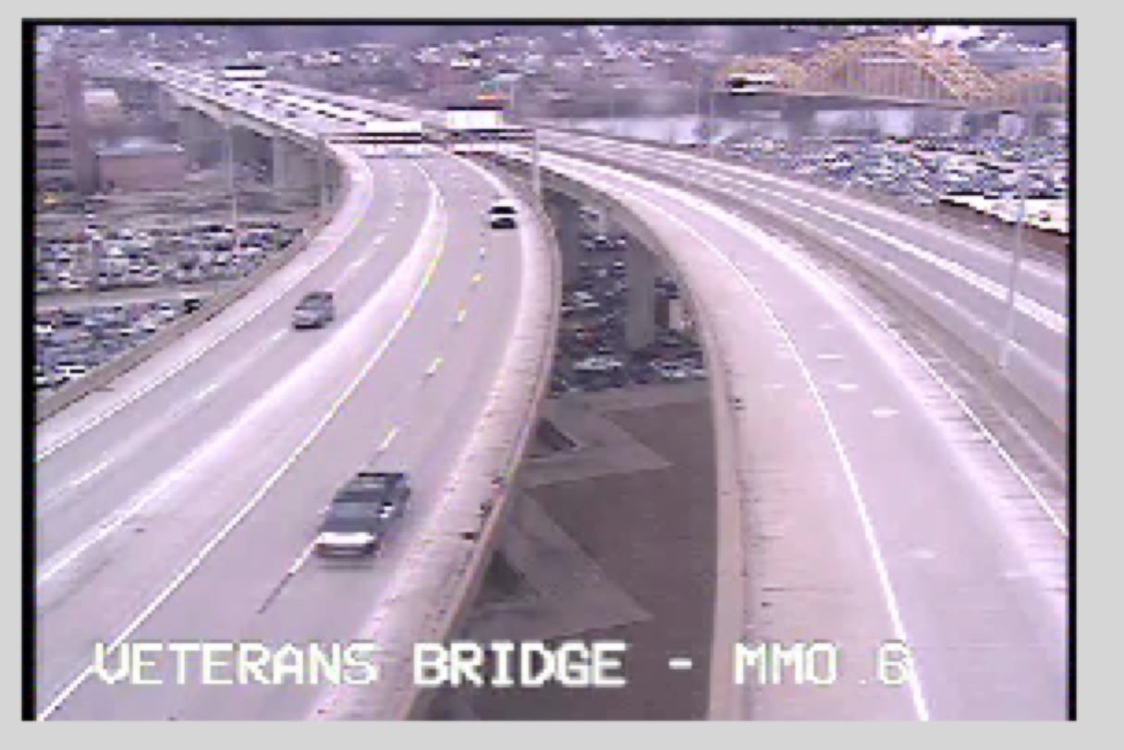

Figure 2a: Original Frame

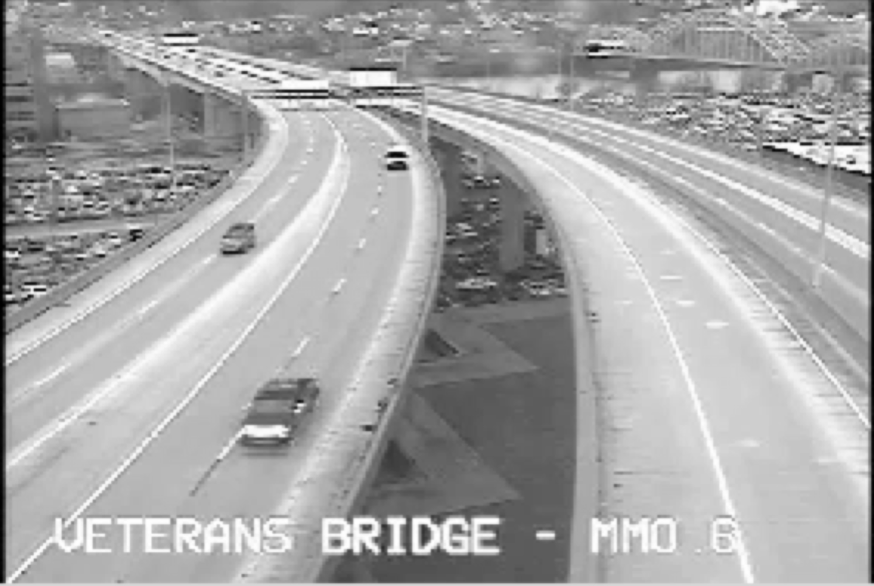

Figure 2b: Background Frame

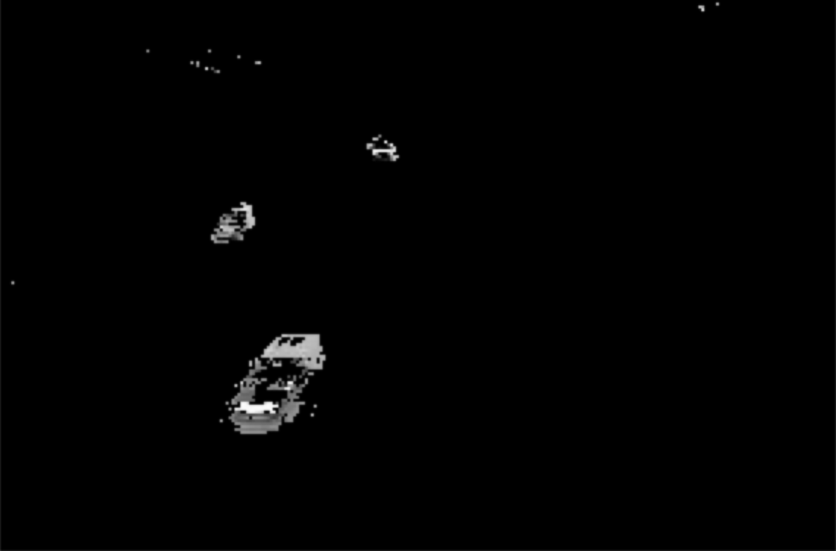

Figure c: Frame-Diff Image

As you can see Figure 2a is the input frame and Figure 2b is the background frame and frame differencing with thresholding effectively removes all objects in the background (as shown by Figure 2c). The other background subtraction method used was by means of the approximate median algorithm. This approximate median algorithm works as follows: If a pixel in the current frame has a value larger than the corresponding background pixel, the background pixel is incremented by 1. If the current pixel is less than the background pixel, the background is decremented by one. The background eventually converges to an estimate where half the input pixels are greater than the background, and half are less than the background—approximately the median [11].  The results of using this algorithm are comparable to that of frame differencing and will be expanded on as part of the Results section later in this paper.

*Filter Tracked Objects*

Once we have this frame-differenced image as seen by Figure 2c we can perform simple filtering to remove “salt and pepper” noise and also fill in missing spaces in the image in order to clearly identify vehicles. In order to get rid of the noise we can perform median filtering. Median filtering is the process of running through an image pixel by pixel and replacing each pixel with the median of its neighboring pixels. The process of “filling in” holes in the filtered image can be achieved by performing morphological processing. The specific morphological close operation used for the purposes of this paper was a morphological dilation followed by morphological erosion. During the process of a morphological dilation every background pixel that is touching an object pixel (object in this case is the vehicle) is changed into an object pixel. During morphological erosion every object pixel that is touching a background pixel is turned into a background pixel. The result of this combined filtering and morphological processing is shown in Figure 3.

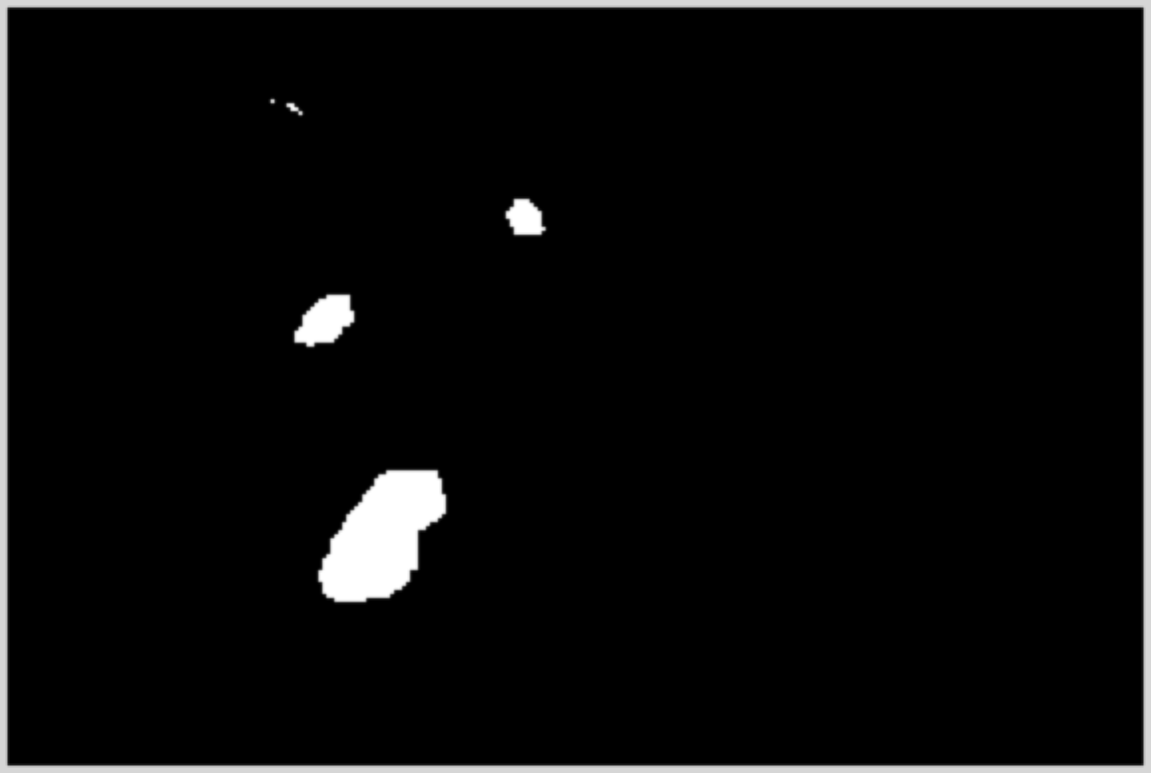

Figure 3: Morphologically altered frame

*Determine Centroid Coordinates of Moving Objects*

Once we have isolated the moving vehicles as shown in the figure above we need to get the centroid coordinates of each of these vehicles in order to track them and eventually calculate a speed. This is easily achieved by grouping pixels that are connected to each other (in our labeled binary image) into “blobs” and determining their coordinates. We can also define a minimum threshold whereby “blobs” are considered vehicles only if they contain a minimum number of pixels. This will prevent the mischaracterization of noise as a vehicle. Centroid coordinates corresponding to the same vehicle frame to frame can be kept track of by using a simple thresholded linear search. The assumption made is that if a centroid coordinate in one frame is close the centroid coordinate in the next frame then both frames must be referencing the same vehicle. In order to reduce variability I keep track of centroid coordinates of multiple vehicles over multiple frames rather than just two frames.

*Calculate Speed of Objects over Multiple Frames*

In order to determine speed the main characteristics required are a distance reference and a time reference. A distance reference can be obtained by calculating the Euclidean distance traveled by a vehicle frame to frame.



As evident by the above equation we can take the x and y centroid coordinates between two frames and derive a distance. The second part to determining the speed of a vehicle is the time taken to travel that set distance. The best metric for this is the frame rate of the original video. In the model used for this paper typically the frame rate was roughly 10 frames per second. If we are looking at just movement between two frames then the time elapsed between frames can be approximated as roughly 2/10 or .2 seconds. Speed can be determined as shown below where C is a calibration coefficient:

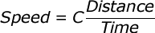

The calibration coefficient is used as means of roughly translating the 2-D pixel distance traveled into its real 3-D distance without having to use geometric transformations based on camera parameters.

*Scale Speed based on Area and Distance from Camera*

The final step to refining this speed calculation is to take into account that distance traveled further from the camera is different from distance traveled closer to the camera. In order to take this into account, areas of “blobs” are used as a metric for how close vehicles are to the camera (larger area signifies the vehicle is closer to the camera and smaller area signifies the vehicle is further away). A relationship can thus be derived between “blob” area and speed. This relationship is mostly linear and can be calculated for each vehicle over a set of frames. As a result, even when vehicles are further away from the camera their speeds can be projected based on this linear fit.

**4. Software or Hardware Modules**

The prototype built to test this algorithm was completely built using MATLAB. MATLAB’s Computer Vision System Toolbox was also extensively used. The interface used to present the speed calculations is in the form of looped images that overlay vehicle speeds as shown by Figure 4.

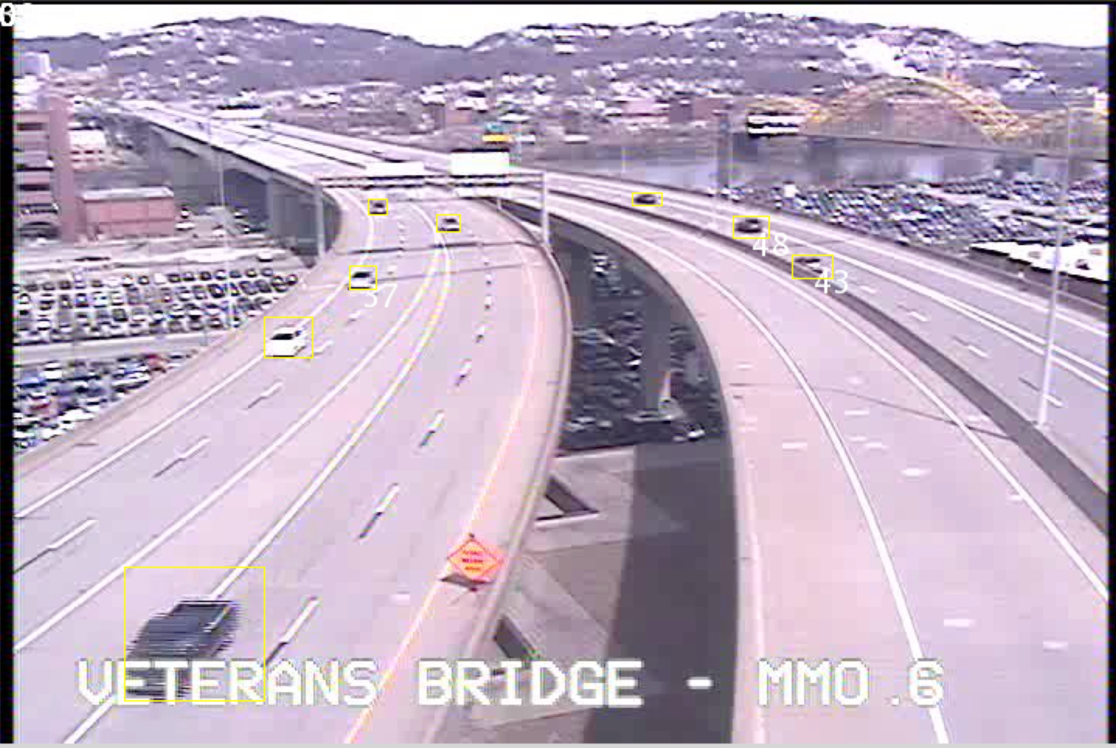

Figure 4: Speed Calculation Overlay

As you can see from the image above vehicles are identified with yellow bounding boxes and speed calculations (if detected) are displayed in white text on the bounding boxes themselves. The images themselves are all of size 720x480. The experiments that will be presented in the next section were all run on an Apple MacBook Pro with a 2.5 GHz Intel Core i5 processor. As a summary of the software modules used and the workflow please refer to Figure 5 below:

Figure : Module Workflow

Live Stream

Process Live Stream Using FFmpeg

Process Frames Using MATLAB

**5. Results**

In this experiment I evaluated the accuracy of my proposed algorithm by comparing the average speed of the vehicles calculated by my system with that of a relative “ground-truth”. The “ground-truth” was calculated manually by observing the car movements over a series of frames and using highway markers as a reference for distance traveled. Due to the fact that all US highways adhere to the same highway marker lengths (white lane markers are 10 feet long and they are spaced 30 feet apart) a fairly accurate “ground-truth” can be established.

The two main data sets used as part of the experiments are of the Veterans Bridge and screenshots of the road conditions for each of the datasets is shown below:

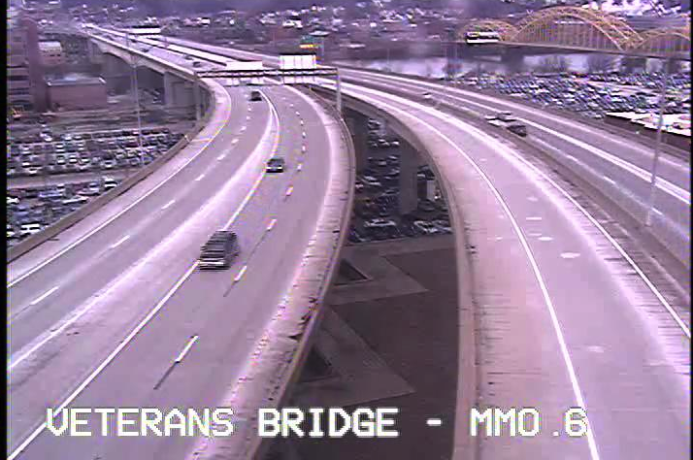

Figure 6: Road Conditions for 257-Frame Dataset

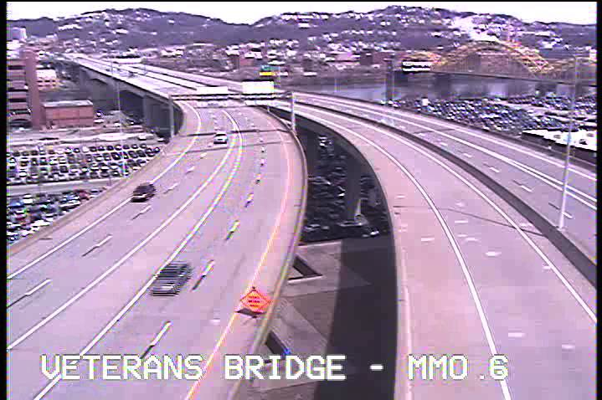

Figure 7: Road Conditions for 390-Frame Dataset

*Experiment 1:*

In the following experiment the data set used was a 257-frame data set of Veterans Bridge. The parameters used for this experiment are found below

* Threshold value for frame differencing = 30 frames
* Filter size for applied median filter = 4x4
* Minimum area required to be considered blob = 50 pixels
* Calibration Coefficient = 1.3
* Threshold distance for matching vehicle from frame to frame = 10 pixels
* Frame window = 3 Frames

In this experiment speed was calculated and output by the system after looking at a window of 3 frames at a time. One of the key assumptions being made in this experiment is that the vehicles are traveling between 35-55 m.p.h. After the speeds are initially calculated they are checked to see if they fall within the expected range or not. If they are deemed to be outside of the expected range then they undergo a scaling based on area. This measure is in place to try and compensate for the fact that cars further from the camera have a different distance scaling compared to cars closer to the camera. In the case that within a 3-frame window there are multiple speeds reported for the same vehicle I average the speeds to get one speed. Because the total number of frames travelled by one car is large and our window is relatively small, the algorithm reports multiple speeds for each car as you can see below. In order to compare these speeds to a single “ground-truth” we can take an average of these speeds and compare.

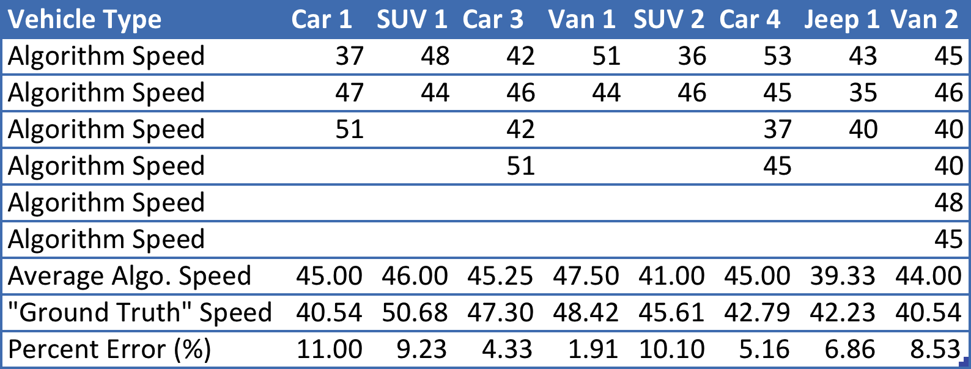

Table : Results for Experiment 1

*Experiment 2:*

In this experiment the parameters and data sets are the same as Experiment 1 except for the fact that we use the approximate median algorithm for background subtraction instead of frame differencing. Results are shown below:

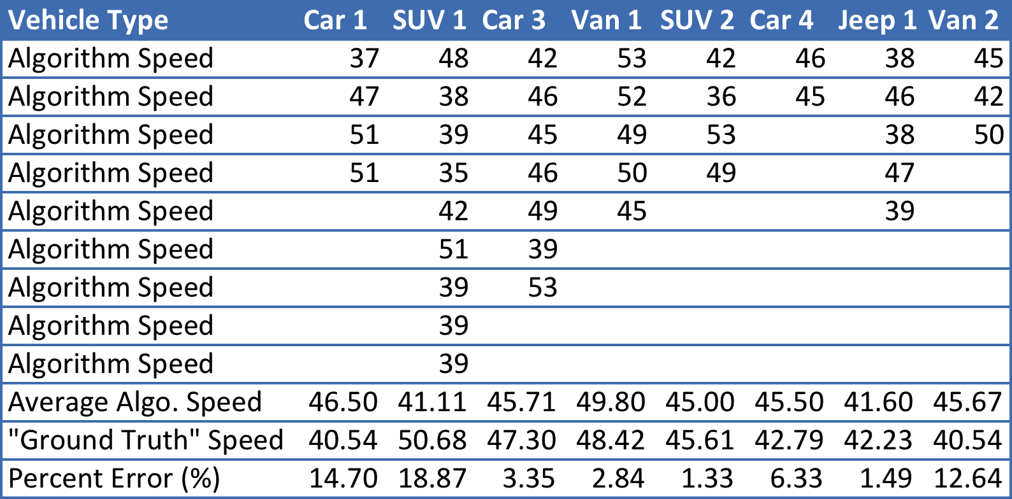

*Experiment 3:*

Table : Results for Experiment 2

In this experiment we have a few slight differences from Experiment 1. With regards to parameter changes the only changes are shown below:

* Calibration Coefficient = 1.3
* Frame window = 10 Frames

In this experiment the speed calculations are done slightly differently as we have more data (speed calculations over a span of 10 frames). I also impose less restrictive bounds in terms of the speeds output by the system. Speed and area data are collected and stored over this span of 10 frames. Once this data is collected a linear relationship is drawn between speed and area for each car. Then a speed is projected using this linear relationship. If this projection yields a result that is outside of our expected speed bounds (35 to 55 m.p.h.) then I just take the average of the speed data collected and that is the speed, which is output by the system. The results of this methodology are shown below:

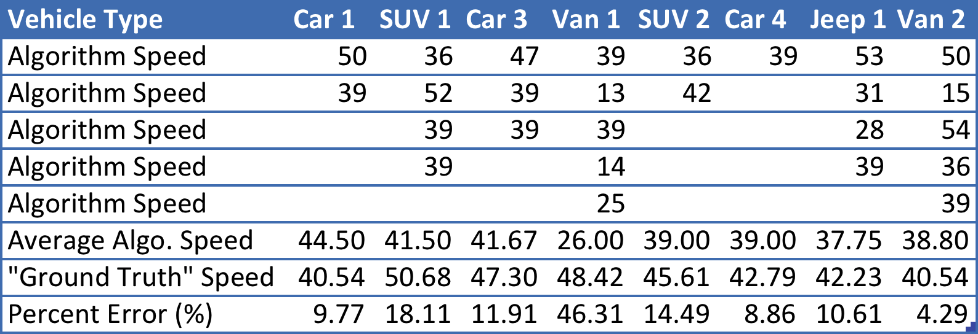

Table : Results for Experiment 3

*Experiment 4:*

This experiment is identical to Experiment 1 except for a change to a new 390-frame dataset of Veteran’s bridge and a change of the Calibration Coefficient to a value of 1.1.

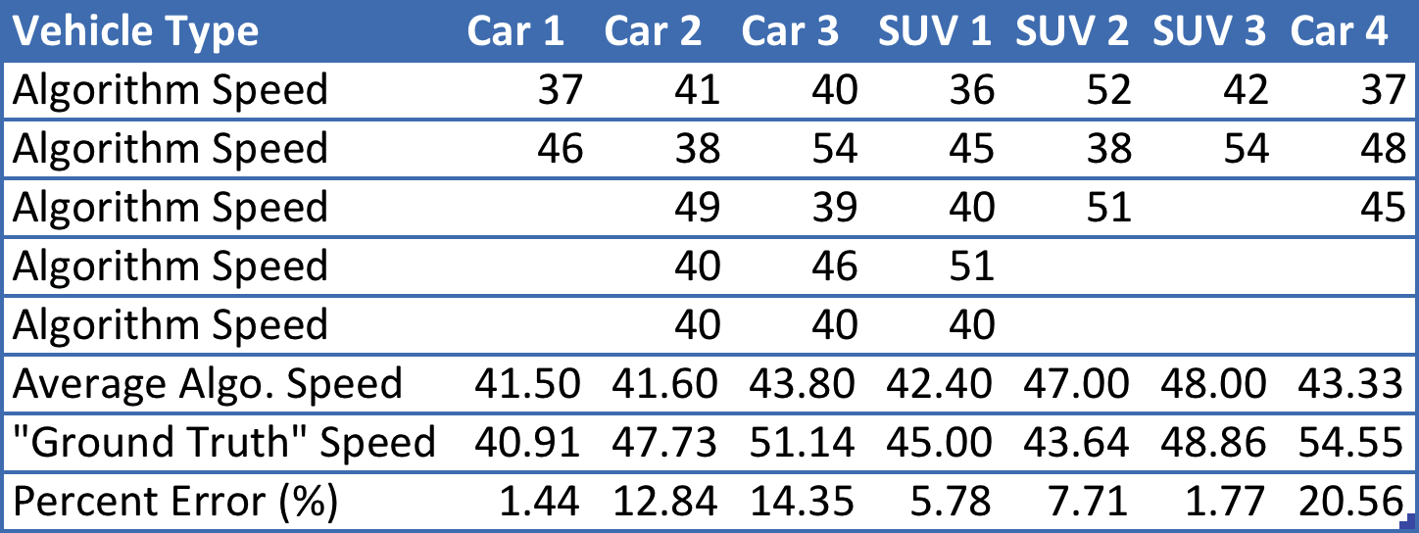

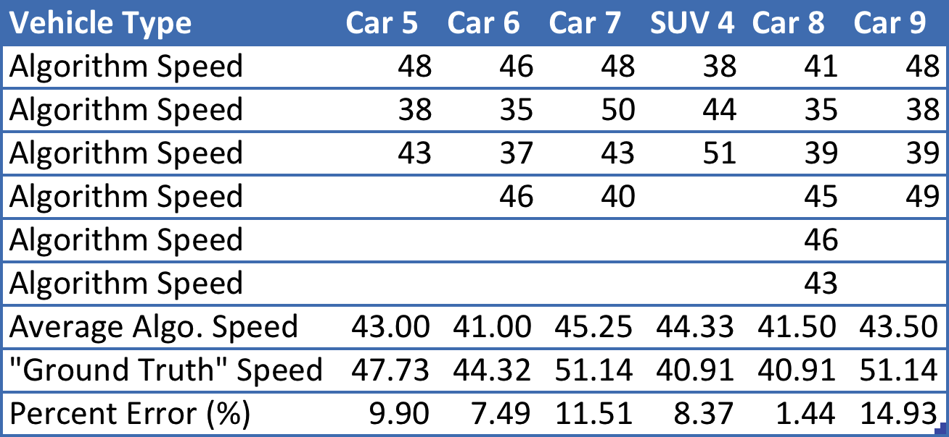

Table : Results for Experiment 4

*Experiment 5:*

This is the same experiment as Experiment 2 except with the 390-frame dataset and a Calibration Coefficient of 1.1.

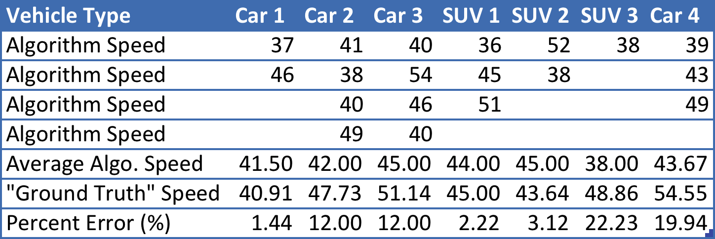

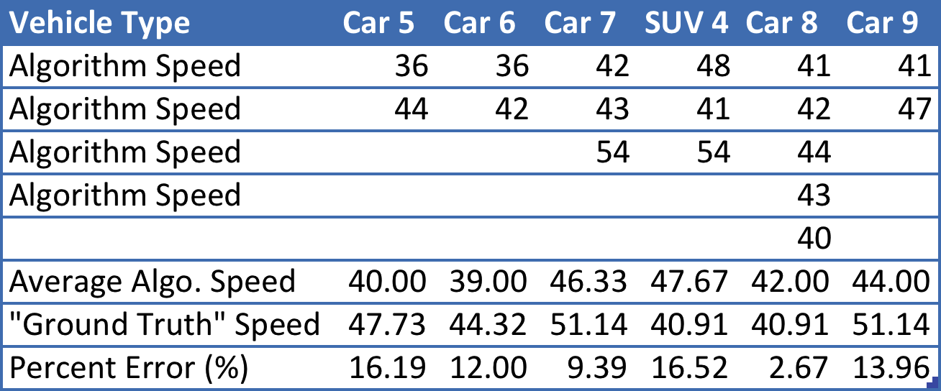

Table : Results for Experiment 5

*Experiment 6*

This experiment is the same as Experiment 3 except with the 390-frame dataset and a Calibration coefficient of 1.2.

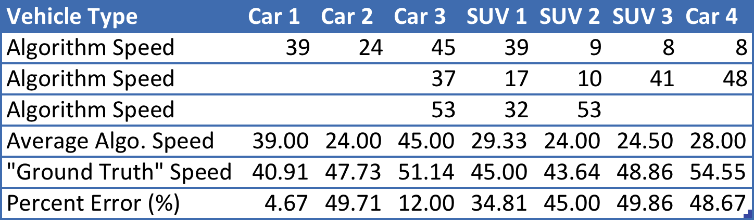

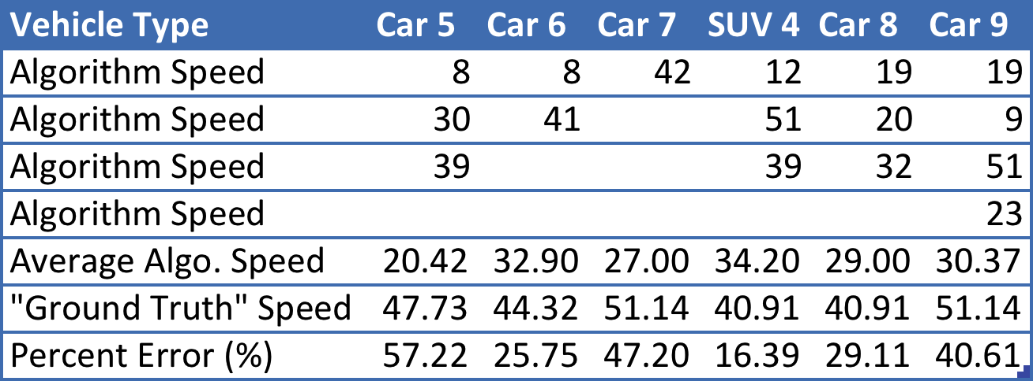

Table : Results for Experiment 6

**6. Analysis**

*Analysis of Own Results*

In order to get a better understanding of the data that has been presented in the previous Results section I will first walk through experiments 1-3 individually and then compare the results collectively. Looking at experiment 1 we can see that one of the key assumptions and constraints with regards to the output provided by the system is that the cars travel only between 35-55 m.ph. This assumption was a necessary assumption because since there was no 3-D model (or other model that could accurately gauge distance in relation to the camera) the problem had to be simplified. Another design choice was to calculate speeds between consecutive frames and to look at the speeds over a span of multiple frames (in this case 3). So for example if we look at the first 3-frame window we would be able to look at the speed between frames 1-2 and 2-3. After obtaining these speeds I was able to either average them (if they were within expected bounds) or use a linear fit based on area to project what the speed should be (since I assume that if the speeds are out of bounds then that means the cars are too far from the camera and their distance traveled is being scaled incorrectly). One disadvantage of having such a small window size and only calculating speeds between consecutive frames is that as the vehicle travels throughout the entire scene/frame there are multiple speeds that are being reported. As you can see from the table from experiment 1, Van 2 reports almost 6 different speeds. In order to compare these results to a “ground-truth” I decided to average these different speed-readings and compare. The form of comparison I chose was to calculate the percent error between the measured and “ground-truth” value. As you can see with Experiment 1, error rates are between 2-11%. We can see with Experiment 4 (which is a mirror of Experiment 1 except with a different data set) that error rates are as low as 1.4% and as high as 21%. If we average out the error rates over all of our samples (including Experiment 1 and Experiment 4) we are looking at an error rate of roughly 8.3%. The fact that each vehicle reports so many varied speeds in such a short time span can be attributed to the fact that we are only calculating speeds between consecutive frames and instead if we had a running average type of model perhaps we could get more stable results. As a whole (given the assumptions we have made) these results look fairly promising. The next set of experiments to look at is Experiment 2 and 5. The only main difference between this set of experiments and the previous one was that I wanted to test and see if perhaps using a different more stable background subtraction method would yield better speed-readings. Looking at both Experiment 2 and 5 there are error rates as low as 1.3% and as high as 22.3%. These min-max ranges are very similar to those seen in Experiment 1 and 4. Again taking an average of the error rates over the entire sample space yields a total error of about 9.7%. This very small difference in error rate between approximate median background subtraction and frame differencing makes me believe that frame differencing is preferable due to its ease in terms of implementation. Experiment 3 and 6 are pretty much similar to the previous experiments in terms of how the background is extracted, centroids calculated, etc. but the main difference is in how the speed is calculated and also the fact that the window of frames being looked at is larger. As was explained in the Results section under Experiment 3, this speed calculation was meant to be less constrained than the previous sets of experiments and was meant to show the effects of not tightly limiting the outputs and setting an expected speed boundary. Since cases where the area based projection provided speeds outside the expected limit results in just an averaging of already seen speeds, all the speeds were not corrected to fit within our expected range. Our linear fit/projection however was more accurate than with the previous experiments because our linear fit was based on more data points since we are looking at a window of size 10. This less constrained approach seems more realistic since we won’t necessarily always know what range to expect vehicles to be traveling, especially in sudden emergency situations (such as with accidents, inclement weather, construction, etc.) Looking at the results however from Experiment 3 and 6 we can see that by essentially removing the tight speed output constraints the error rates are significantly higher than with the previous sets of experiments. Experiment 3 has error rates ranging from 4-46% and error rates as high as 57%. Taking a total average over all samples gives us an error rate of about 28%. This averaged error rate is almost 3 to 4 times larger than the previous more constrained experiments. Although I do feel that this larger framed approach may be more practical as there are less assumptions being made in comparison to the previous sets of experiments.

*Comparison to Other Work*

As was alluded to in the introduction there have been many research papers written on this subject and many have published their results. Dailey and Li [3] used known vehicle length distributions along with frame differencing and achieved error rates as high as 30%. Xiao and Yung [2] implement a block matching and camera calibration technique that yields only a 3.27% error rate. In their paper Xiao and Yung [2] also reference other work by Dailey and make the claim that most other estimation methods yield at least 10% error. Alcantarilla, Sotelo, and Bergasa [7] show that their method of Kalman filtering tracking and shadow removal yields results that are consistently within 10 km/h of their “ground-truth”. Dailey, Cathey, and Pumrin [12] expand on Dailey’s other previously mentioned work and use Sobel filters and geometric relationships inherent in the images to achieve results that are consistently within one to two standard deviations from the measured “ground-truth”. They also use a similar method of determining the “ground-truth” as me. They perform a manual calibration based on the lengths and physical dimensions of the lane markers on the roadway. All of these results by researchers seem to indicate a rather large range of success. The general statement made by Xiao and Yung seems to hold true that most methods yield at least 10% error, and that most effective techniques are around that range. Because each researcher defines their ground truths differently it is difficult to have a uniform form of comparison. Now comparing my results with those of these other findings it seems reasonable to assert that my findings are in the higher end of the error rates compared to other research. Most of the work done by Dailey, Li, etc. seems to be able to capture consistent results whereas my methods seem to have very high variability and volatility. However by taking an average of these variable results we can see that my methods seems to be in the general ball park and seem to be consistent with other estimation techniques. One factor that must be considered in terms of comparing my work to other work is the types of assumptions that were made when carrying out the experiments and implementing the algorithms. My simplifying assumptions cannot necessarily be applied to all situations such as lower speeds or higher density of traffic whereas other methods such as those proposed by Dailey can be. Hence my methods seem to be reasonable as a general barometer and estimation of traffic vehicle speed but may not achieve the accuracy and consistency of other proposed methods.

**7. Conclusion**

In conclusion I have proposed a method whereby simple background subtraction techniques can be paired with scaled speed calculations to provide a reasonable estimation of vehicle speeds. The advantage of my method over other proposed methods is its lack of dependence on calibration, certain geometries, and unknown camera parameters. One of the downsides of my algorithm however, is that by not relying on external parameters or calculating internal geometries, my results are very variable. Despite these downsides I think that my results are encouraging that reasonable speed detection can be achieved by using simpler un-calibrated methodologies.

Given my research and results I believe that several improvements can be made to my system for future work. More accurate results could be obtained perhaps if speed calculations were paired with a vehicle classifier of some sort. Currently the movements of all the vehicles are treated the same when in fact cars would move differently than bigger vehicles like trucks and SUV’s. Future work could include tracking objects over a larger collection of frames and normalizing speed results. This normalization process could be something more substantial than just simple averaging. By having access to more data over more frames a decaying function could be defined whereby bad data points are ignored and more of a running average is calculated in order to maintain consistent and accurate results. Other work could include coming up with a more robust way of projecting the speed of cars that are very far from the camera rather than just using a linear fit based on a few data points. Another point of emphasis for future work can be to compare results of speed detection with a more solid “ground-truth”. This could be in the form of radar data or actually having someone drive along the roads being monitored and keeping track of the speeds traveled by the individual. Many of these suggestions could be implemented alongside many of the other works referenced in this paper to build a robust and cheap alternative to non-video based speed detectors. By building a robust cheap alternative we can not only save hundreds of thousands of dollars for taxpayers but we can also make our roads much safer by having more efficient and timely responses to roadside emergencies.

**8. References**

[1] S. Takaba, M. Sakauchi, T. Kaneko, Hwang Byong Won, and T. Sekine, "Measurement of traffic flow using real time processing of moving pictures," in *Proceeding of 32nd IEEE Vehicular Technology Conference*, vol. 32, pp. 488-494 San Diego, California, USA, 1982.

[2] Xiao, Chen He and Yung, N.H.C., 2007, “A Novel Algorithm for Estimating Vehicle Speed from Two Consecutive Images,” in *Proc. of the IEEE Workshop on Applications of Computer Vision – WAVC’07*, pp.12-17.

[3] D. J. Dailey and L. Li, "An algorithm to estimate vehicle speed using uncalibrated cameras," in *Proceeding of IEEE/IEEJ/JSAI International Conference on Intelligent Transportation Systems*, pp. 441-446, 1999.

[4] T. N. Schoepflin and D. J. Dailey, "Algorithms for calibrating roadside traffic cameras and estimating mean vehicle speed," in *Proceeding of IEEE Intelligent Vehicles Symposium,* pp. 60-65, 2004.

[5] B. Gloyer, H. Aghajan, K. Siu, T. Kailath, “Vehicle Detection and Tracking for Freeway Traffic Monitoring,” in *IEEE Record of the Twenty-Eighth Asilomar Conference on Signals, Systems and Computers*, pp. 970-974, 1994.

[6] G. S. K. Fung, N. H. C. Yung, and G. K. H. Pang, "Camera calibration from road lane markings," *Optical Engineering*, vol. 42, pp. 2967-2977, 2003.

[7] P.F. Alcantarilla, M.A. Sotelo, and L.M. Bergasa, “Automatic Daytime Road Traffic Control and Monitoring System,” in *Proceedings of the 11th International IEEE Conference on Intelligent Transportation Systems,* pp. 944-949, 2008.

[8] D. Middleton, H. Charara, and R. Longmire, “Alternative Vehicle Detection Technologies for Traffic Signal Systems: Technical Report”, February 2009. <http://d2dtl5nnlpfr0r.cloudfront.net/tti.tamu.edu/documents/0-5845-1.pdf>

[9] D. Middleton and R. Parker, “Vehicle Detector Evaluation”, October 2002.<http://d2dtl5nnlpfr0r.cloudfront.net/tti.tamu.edu/documents/2119-1.pdf>

[10] Technology Transfer Program. University of California, Berkeley, 2008. Web. 20 Apr. 2013. <http://www.techtransfer.berkeley.edu/newsletter/08-3/vehicle-detection-with-wireless-sensors.php>.

[11] Benton, Seth. "Background subtraction." EE Times Design. UBM Tech, 10 Aug. 2008. Web. 1 May 2013. <http://www.eetimes.com/design/signal-processing-dsp/4017685/Background-subtraction-part-1-MATLAB-models?pageNumber=2>.

[12] D. J. Dailey, F. W. Cathey, and Suree Pumrin, " An Algorithm to Estimate Mean Traffic Speed Using Uncalibrated Cameras," in *IEEE Transactions on intelligent transportation systems,* pp. 98-107, 2000.

**9. Appendix**

*Methods Attempted*

Over the course of this research I attempted many other methods for vehicle speed detection that either didn’t produce viable results or did not have the necessary outside information necessary to make a working model. In this section I will briefly cover some of these attempted methodologies. One of the first things I tried doing was to make use of the calibration technique described by Xiao and Yung [2]. Their conversion from a 2-D to 3-D model was based on a perspective camera model and required key pieces of information such as camera height and tilt angle to calculate the other camera and calibration parameters. Unfortunately because I was unable to procure these parameters I couldn’t accurately calculate the parameters. I estimated the height and angles and tried various guesses as to what these parameters might be but none of them seemed to yield accurate results when I proceeded to carry out my speed detection. Another method that was attempted was to use the foreground detector library found as part of the MATLAB Computer Vision Toolbox instead of using the frame differencing and approximate median techniques that were eventually used. While using the foreground detector library I attempted to perform object detection and tracking with the video input all at once rather than pre-process the video into frames as I eventually ended up doing. The foreground detector used Gaussian Mixture Models to subtract away the background and seemed to work fairly well but the results seemed comparable to what I eventually was able to get with the easier background subtraction techniques. Another method that seemed viable and that was attempted was to try and use a proportion-based approach to estimate vehicle speeds. In order to do this I essentially set up a grid system on the frame that had horizontal lines set up at each lane maker. Because it was known that these lane markers were 10 feet I tried to set up an automatic calibration whereby depending on the region where the vehicle was the speed would be calculated based on the length of the nearest lane marker. The only downside to this technique was that it required the user to manually specify the pixel values of where each lane marker started and stopped. Even after specifying this I was unable to get results that were close to the neighborhood of the ground truth. If this methodology had been further explored it could have potentially provided an automated calibration tool for measuring “ground-truth”.